Software Requirements Specification

for

SC2006 LAB 2

**Version 1.0 approved**

**Prepared by**

**HIRASHIMA SHUNYA**

**LEE CI HUI**

**LINCH LIM DE ZHI**

**SIM OI LIANG**

**Nanyang Technological University, SSP2, Team 04, Milky Shake**

**13th September 2022**

Table of Contents

### Overview 1

### Refined Use Case Model

#### Use Case Diagram 2

#### Use Case Descriptions 3

### Build the Conceptual Model

#### Class Diagram of Entity Classes 21

#### Key Boundary Classes and Control Classes 22

### Build the Dynamic Model

#### Sequence Diagrams 23

#### State Machine Diagram 30

# Overview

After receiving feedback from Lab 1, our team revised the first deliverables and refined them accordingly. From here, we developed the Analysis Model as the basis of our system design which included Conceptual Model and Dynamic Model based on the refined deliverables from Lab 1. This document mainly serves as the summary of expected deliverables in Lab 2 and the corresponding details.

# Refined Use Case Model

### 2.1. Use Case Diagram

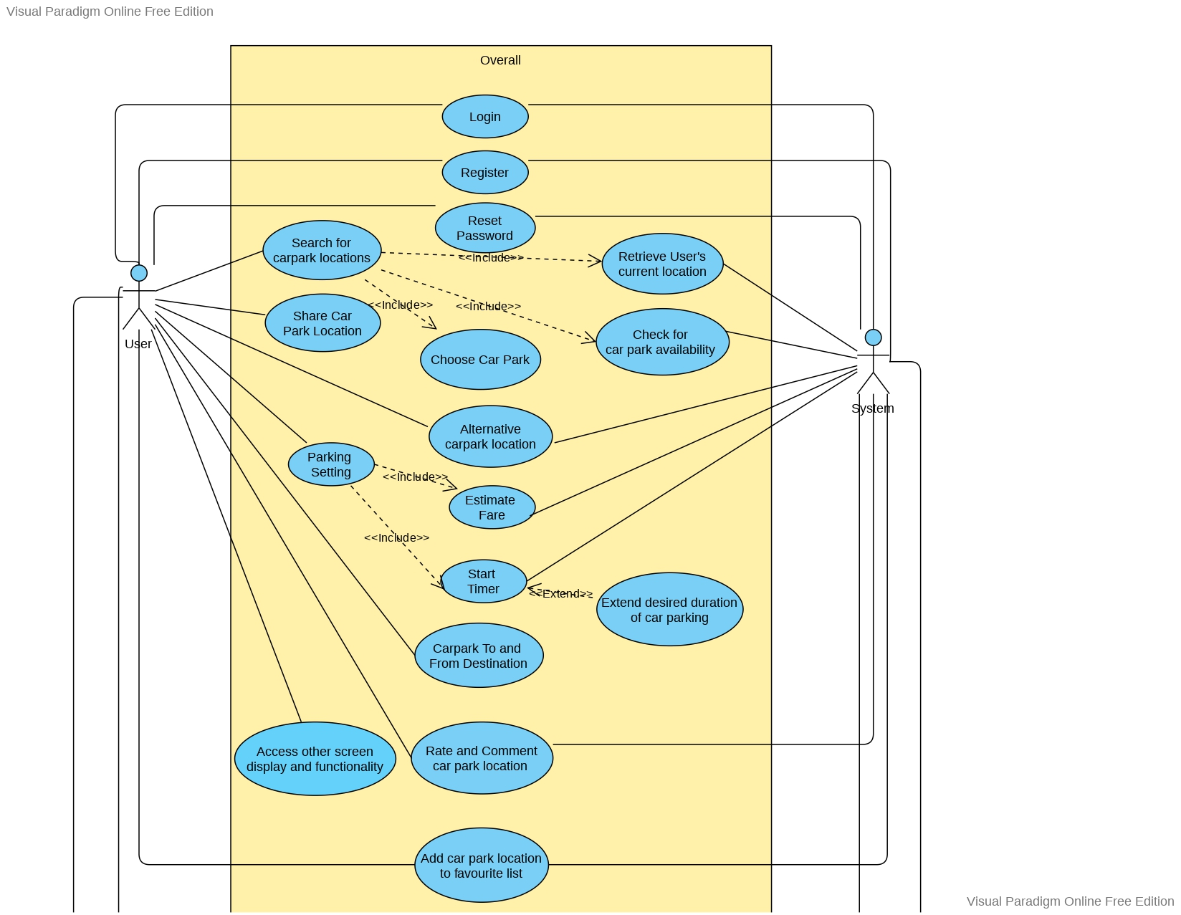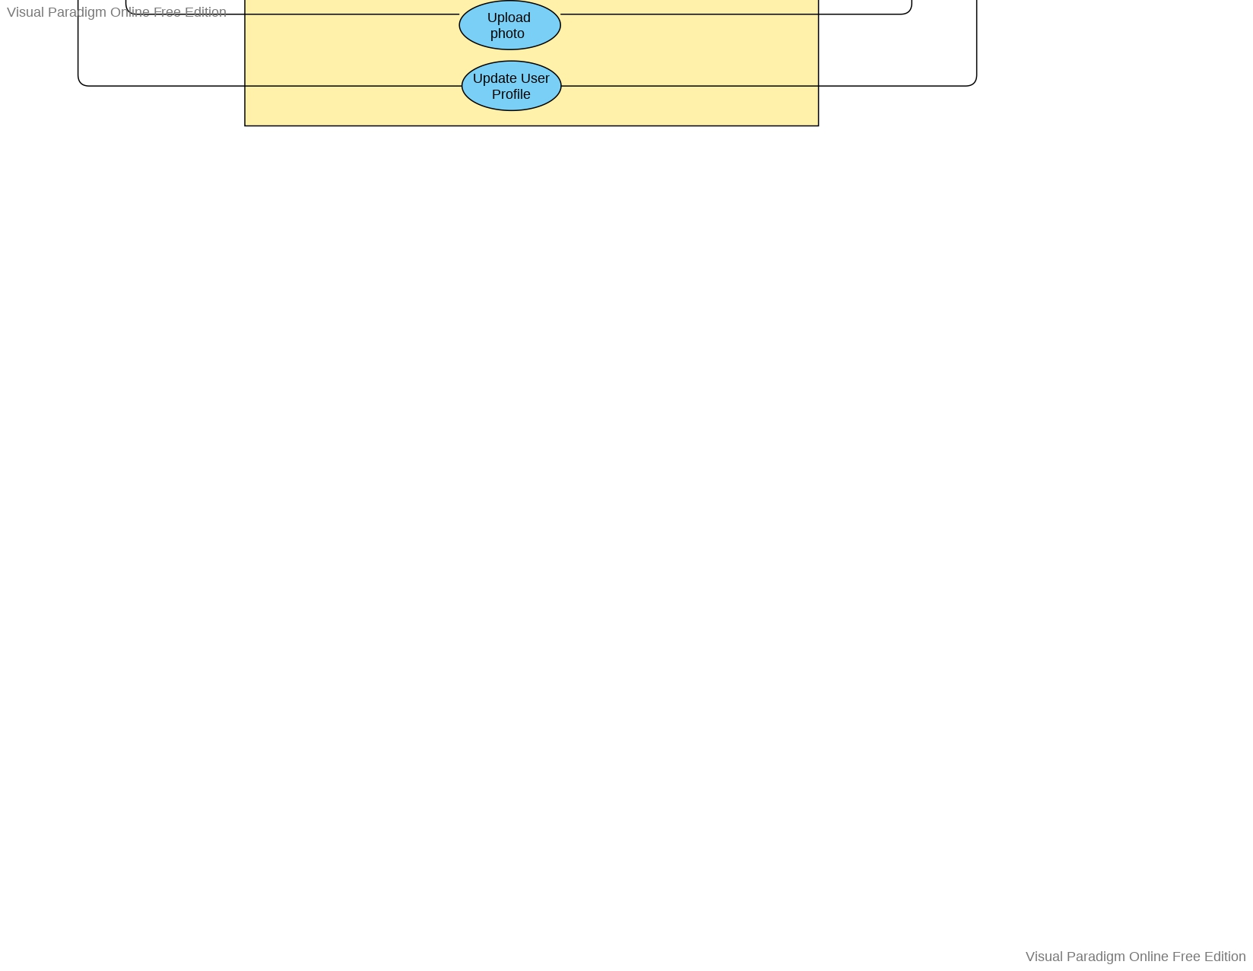

### 2.2. Use Case Diagram

Use Case 1

| Use Case ID: | 1 | | |
| --- | --- | --- | --- |
| Use Case Name: | Login to User Account | | |
| Created By: | Hirashima Shunya | Last Updated By: | Hirashima Shunya |
| Date Created: | 30th August 2022 | Date Last Updated: | 30th August 2022 |

| Actor: | User |
| --- | --- |
| Description: | Account login process through email address and password. |
| Preconditions: | 1. User accounts must exist in the database. 2. The system is on the login page. |
| Postconditions: | 1. A user must be able to access the user’s Favourite list. 2. A user must be able to access the user’s searching history. |
| Priority: | Medium |
| Frequency of Use: | 1 – 3 times per lifetime |
| Flow of Events: | 1. User enters an email address and password in the login interface. 2. User selects the login button. 3. The system validates the email address and password. 4. The system verifies the account by checking the user’s credentials stored in a cloud database. 5. The system authenticates the user to login successfully by direct user to Home screen. |
| Alternative Flows: | AF-S3: If the system detects empty email address or password fields   1. The system displays an error message “Please input both email address and password.” 2. Return to Step 1.   AF-S4: If user enters the wrong credentials   1. The system displays an error message “Either address or password is wrong. Please try again.” 2. Return to Step 1. |
| Exceptions: | - |
| Includes: | - |
| Special Requirements: | - |
| Assumptions: | A user account must be accessed from a cloud database. |
| Notes and Issues: | - |

Use Case 2

| Use Case ID: | 2 | | |
| --- | --- | --- | --- |
| Use Case Name: | Register for a New Account | | |
| Created By: | Hirashima Shunya | Last Updated By: | Hirashima Shunya |
| Date Created: | 30th August 2022 | Date Last Updated: | 2nd September 2022 |

| Actor: | User |
| --- | --- |
| Description: | Registration for a new user account. |
| Preconditions: | 1. The window is on the Login page. |
| Postconditions: | 1. A new account is created and stored on a cloud database. |
| Priority: | Medium |
| Frequency of Use: | 1 – 3 times per lifetime |
| Flow of Events: | 1. User taps the “sign up” button. 2. User inputs first name, last name, email address, and password. 3. User taps the “register” button. 4. The system validates the user inputs. 5. The system verifies the account by checking the availability of user's account in the cloud database. 6. The system creates a new account for the user in the cloud database. 7. The system sends a verification email to user’s email. 8. After user clicks on the verification link, the system activate the new account. |
| Alternative Flows: | AF-S4: The user inputs an invalid email address   1. The system displays an error message, “Invalid address. Please input a valid address.” 2. Return Step 2.   AF-S4: The user inputs an invalid password   1. The system displays an error message “Invalid password. Please input a valid password by referring to the conditions below.” 2. Return Step 2.   AF-S5: The system detect account existed in the cloud database   1. The system displays an error message “Account already exists. Please try again.” 2. Return Step 2.   AF-S8: The system did not receive confirmation by the verification link.   1. The system will not activate the new account until confirmation. |
| Exceptions: | - |
| Includes: | - |
| Special Requirements: | - |
| Assumptions: | A user account must be stored in a cloud database. |
| Notes and Issues: | - |

Use Case 3

| Use Case ID: | 3 | | |
| --- | --- | --- | --- |
| Use Case Name: | Change Password | | |
| Created By: | Hirashima Shunya | Last Updated By: | Hirashima Shunya |
| Date Created: | 30th August 2022 | Date Last Updated: | 2nd September 2022 |

| Actor: | User |
| --- | --- |
| Description: | Alteration of a user account password. |
| Preconditions: | 1. A user account must exist in the database. 2. The window is on the Login page. |
| Postconditions: | 1. A new password replaces the old one in a cloud database. |
| Priority: | Medium |
| Frequency of Use: | 1 – 3 times per lifetime |
| Flow of Events: | 1. User taps “Forget password” strings. 2. User enters an email address for an existing account. 3. The system validates the user's input. 4. The system verifies the account by checking the user’s email stored in a cloud database. 5. The system sends an email to the user's email to reset the password. 6. User inputs a new password and taps the “update” button. 7. The system checks the validity of the new password. 8. The system updates the password in the cloud database. |
| Alternative Flows: | AF-S3: If the system detects empty email address field.   1. The system displays an error message “Please input an email address.” 2. Return to Step 2.   AF-S4: If input address is not found on a database   1. The system lets the user input email address again, displaying an error message, “Input email address is not found. Please input an address that you register for”. 2. Return to Step 2.   AF-S7: If user’s new password is not valid   1. The system displays an error message “Invalid password. Please input a valid password by referring to the conditions below.” 2. The system lets the user input another password to be valid. 3. Return to Step 6. |
| Exceptions: | - |
| Includes: | - |
| Special Requirements: | - |
| Assumptions: | - A user account can be accessed from cloud databases. |
| Notes and Issues: | - |

Use Case 4

| Use Case ID: | 4 | | |
| --- | --- | --- | --- |
| Use Case Name: | Add Car Park to Favorite List | | |
| Created By: | Hirashima Shunya | Last Updated By: | Hirashima Shunya |
| Date Created: | 30th August 2022 | Date Last Updated: | 2nd September 2022 |

| Actor: | User |
| --- | --- |
| Description: | Addition of Car Park to Favorite List. |
| Preconditions: | 1. The window is on either the user profile or the end of the car parking page. |
| Postconditions: | 1. A selected car park is added to a favorite list. |
| Priority: | High |
| Frequency of Use: | 0 - 5 times per day |
| Flow of Events: | 1. User taps an unfilled heart-shaped diagram shown beside the Car Park description. 2. The system retrieves the selected car park information from the CarparkAPI. 3. The system verifies the existence of the selected car park in the user’s favorite list in the cloud database. 4. The car park is added to the user’s favorite list. The heart-shaped diagram is filled with red. |
| Alternative Flows: | AF-S3: If the selected car park already existed in the user's favorite list.   1. The system displays a pop-up notification “This car park has already been in your favorite list. Would you like to delete it?” with “Yes” and “No” tabs. 2. If user taps “Yes”, the system will remove the selected car park from the user's favorite list in the cloud database. |
| Exceptions: | - |
| Includes: | - |
| Special Requirements: | - |
| Assumptions: | - |
| Notes and Issues: | - |

Use Case 5

| Use Case ID: | 5 | | |
| --- | --- | --- | --- |
| Use Case Name: | Upload Photo for User Profile | | |
| Created By: | Hirashima Shunya | Last Updated By: | Hirashima Shunya |
| Date Created: | 30th August 2022 | Date Last Updated: | 2nd September 2022 |

| Actor: | User |
| --- | --- |
| Description: | Uploading a photo used for an icon of a user profile. |
| Preconditions: | 1. The window is on the user profile page. |
| Postconditions: | 1. An icon photo of a user profile is updated. 2. The photo is stored on a cloud database. |
| Priority: | Medium |
| Frequency of Use: | 1 - 3 times per lifetime |
| Flow of Events: | 1. User taps the profile icon. 2. The system displays a notification with messages “change photo” and “not now”. 3. User taps the “change photo” block. 4. The system accesses and displays the user’s photo album. 5. User chooses a photo from the user’s photo album. 6. User confirms a photo. 7. The system returns the window to the user profile page and the icon photo is updated. |
| Alternative Flows: | AF-S2: If a user taps the “not now” block   1. The system returns the window to the user profile page.   AF-S4: The system unable to access user’s photo album   1. The system displays an error message “Unable to access photo album. Please allow permission” |
| Exceptions: | - |
| Includes: | - |
| Special Requirements: | - |
| Assumptions: | - jpg and png files are supported. |
| Notes and Issues: | - |

Use Case 6

| Use Case ID: | 6 | | |
| --- | --- | --- | --- |
| Use Case Name: | Search for Car Park Locations | | |
| Created By: | Hirashima Shunya | Last Updated By: | Hirashima Shunya |
| Date Created: | 30th August 2022 | Date Last Updated: | 2nd September 2022 |

| Actor: | User |
| --- | --- |
| Description: | Search for Car Park Location as a user’s destination. |
| Preconditions: | 1. The window is on the Home page. |
| Postconditions: | 1. The system accepts the departure location and the destination. 2. The system displays a map interface showing pointers on car parks near to the selected destination. |
| Priority: | High |
| Frequency of Use: | 0 - 10 times per day |
| Flow of Events: | 1. User taps a searching blank displaying “Find Carpark”. 2. The system moves to the “Search Start Location and Destination” page. 3. The system pops up “choose current location” as an option bar. 4. User inputs a departure location in the blank, which is set as a departure location by the system. 5. User inputs a destination, which is set as a destination by the system. 6. User taps the “Search” button. 7. The system checks for car park availability near the destination. 8. The system displays car parks near to the destination. |
| Alternative Flows: | AF-S7: If a user inputs nothing on the departure location blank   1. The system sets the departure location as the user’s current location 2. The system retrieves the user’s current location. 3. Return to Step 7. |
| Exceptions: | Ex1: If a user does not give a permission of using the current location and the system attempts to set the departure location as the current location   1. The system displays an error message: “Please give permission for the usage of the current location or input the departure location.” |
| Includes: | 1. Retrieve User’s current location 2. Check for Car Park Availability 3. Choose car park |
| Special Requirements: | - |
| Assumptions: | 1. At least one option can be found. |
| Notes and Issues: | - |

Use Case 7

| Use Case ID: | 7 | | |
| --- | --- | --- | --- |
| Use Case Name: | Check for Car Park Availability | | |
| Created By: | Hirashima Shunya | Last Updated By: | Hirashima Shunya |
| Date Created: | 30th August 2022 | Date Last Updated: | 2nd September 2022 |

| Actor: | System |
| --- | --- |
| Description: | Check whether the respective car park is available. |
| Preconditions: | 1. At least one car park is fetched from Google Maps API. 2. The user had chosen a destination location. |
| Postconditions: | 1. The checked availability is sent to the user interface for searching functionality. |
| Priority: | High |
| Frequency of Use: | 0 - 10 times per day |
| Flow of Events: | 1. The system fetches car parks near to the selected destination from Google Maps API. 2. The system fetches information about availability of each car park. 3. The availability data is tied to the car park location. The availability data is shown on the “Carpark Selected” page. 4. The system repeats updating the car park availability as a background process after a car park is selected. |
| Alternative Flows: | - |
| Exceptions: | - |
| Includes: | - |
| Special Requirements: | - |
| Assumptions: | - |
| Notes and Issues: | - |

Use Case 8

| Use Case ID: | 8 | | |
| --- | --- | --- | --- |
| Use Case Name: | Retrieve User’s current location | | |
| Created By: | Hirashima Shunya | Last Updated By: | Hirashima Shunya |
| Date Created: | 30th August 2022 | Date Last Updated: | 2nd September 2022 |

| Actor: | System |
| --- | --- |
| Description: | Retrieval of user’s current location. |
| Preconditions: | 1. User gives a permission for the application to access the current location. |
| Postconditions: | 1. The retrieved current location can be used as a departure location in search functionality. |
| Priority: | High |
| Frequency of Use: | 0 - 10 times per day |
| Flow of Events: | 1. The system displays a pop-up window. The uppermost bar of the window displays a bar with the message “use the current location.” 2. User taps the “use the current location” bar. 3. The current location is retrieved from the Google Map API and GPS. |
| Alternative Flows: | AF-S2: If a user does not give a permission to use the current location   1. The uppermost message changes to be “no permission to use the current location.” |
| Exceptions: | - |
| Includes: | - |
| Special Requirements: | - |
| Assumptions: | - |
| Notes and Issues: | - |

Use Case 9

| Use Case ID: | 9 | | |
| --- | --- | --- | --- |
| Use Case Name: | Choose Car Park | | |
| Created By: | Hirashima Shunya | Last Updated By: | Hirashima Shunya |
| Date Created: | 30th August 2022 | Date Last Updated: | 2nd September 2022 |

| Actor: | User |
| --- | --- |
| Description: | To pick a car park as a user’s destination. |
| Preconditions: | 1. The system is on the Home page or the Search page. 2. User taps the “Search” button on the Home page. |
| Postconditions: | 1. The selected car park is displayed on the Search page as a destination. 2. The system calculates a route for driving. |
| Priority: | High |
| Frequency of Use: | 0 - 10 times per day |
| Flow of Events: | 1. The system displays 2 dropdown menus: the one determines the category of sorting and the other determines the order of the result display. 2. The system displays 3 of candidates on the bottom side of the user interface with trivial information including the distance and the time to be taken. 3. The system displays candidate car parks near to the destination in Google Maps in a pointer form. 4. User taps the right-handed arrow symbol with respect to one of the candidate car parks. 5. The system displays detailed information about the car park. 6. The user pushes the navigate button. 7. The system determines trails to car park location using Google Map API. 8. The system displays the trail to car park location on the map until user reach destination or user press “Close” button. |
| Alternative Flows: | AF-S4: If user desires to choose the other car park   1. User taps a left hand-sided arrow symbol displayed on the “Carpark Selected” page. 2. Return to Step 2. |
| Exceptions: | - |
| Includes: | - |
| Special Requirements: | - |
| Assumptions: | - |
| Notes and Issues: | - |

Use Case 10

| Use Case ID: | 10 | | |
| --- | --- | --- | --- |
| Use Case Name: | Share Car Park Location | | |
| Created By: | Hirashima Shunya | Last Updated By: | Hirashima Shunya |
| Date Created: | 30th August 2022 | Date Last Updated: | 2nd September 2022 |

| Actor: | User |
| --- | --- |
| Description: | Allow user to share the car park location. |
| Preconditions: | 1. User reach destination   OR   1. User press the “Close” button after navigation. |
| Postconditions: |  |
| Priority: | High |
| Frequency of Use: | 0 - 10 times per day |
| Flow of Events: | 1. User presses the “Share” button. 2. The system displays the sharing options. 3. User chooses a sharing option. 4. The system shares the car park’s information to user’s sharing options. |
| Alternative Flows: | - |
| Exceptions: | - |
| Includes: | - |
| Special Requirements: | - |
| Assumptions: | - |
| Notes and Issues: | - |

Use Case 11

| Use Case ID: | 11 | | |
| --- | --- | --- | --- |
| Use Case Name: | Parking Settings | | |
| Created By: | Hirashima Shunya | Last Updated By: | Hirashima Shunya |
| Date Created: | 30th August 2022 | Date Last Updated: | 2nd September 2022 |

| Actor: | User |
| --- | --- |
| Description: | Allow user to estimate fares, set timer , add images and add notes |
| Preconditions: | 1. User presses the “Start Parking” button and is in the Parking Setting page. |
| Postconditions: | 1. The system displays the navigation for destination or the selected car park. |
| Priority: | High |
| Frequency of Use: | 0 - 10 times per day |
| Flow of Events: | 1. The system displays Estimation, Timer, Add Image, Add Note buttons in the parking setting page. 2. If user selects the Add Image box, then the system saves the image added in the user account in the cloud database and displays the image on the Add Image box. 3. If user enters text in the Add Note box, then the system saves the user’s notes in the user account in the cloud database. 4. If user selects Estimation, then the user uses the included use case Estimation Fare. 5. If user sets a timer by selecting the Timer buttons, then the system saves the user timer in a cloud database. 6. User presses the Continue button. 7. The system displays the Parking Ongoing UI. |
| Alternative Flows: | - |
| Exceptions: | - |
| Includes: | 1. Estimation Fare 2. Start Timer |
| Special Requirements: | - |
| Assumptions: | - |
| Notes and Issues: | - |

Use Case 12

| Use Case ID: | 12 | | |
| --- | --- | --- | --- |
| Use Case Name: | Start Timer | | |
| Created By: | Hirashima Shunya | Last Updated By: | Hirashima Shunya |
| Date Created: | 30th August 2022 | Date Last Updated: | 2nd September 2022 |

| Actor: | System |
| --- | --- |
| Description: | Activation of the set timer. |
| Preconditions: | 1. The system is on the “Parking Ongoing” page. |
| Postconditions: | 1. The timer system activates the set timer. |
| Priority: | High |
| Frequency of Use: | 0 - 10 times per day |
| Flow of Events: | 1. User taps the “Continue” button on the “Parking Settings” page. 2. The system makes the window display the “Parking Ongoing” page. 3. When user taps the “Continue” button on the “Parking Settings” page, the system starts the timer set by the user. 4. The system makes the window display the “Parking Ongoing” page. 5. In the middle of the window, the system makes the window display “alert { set time } mins before end times.” by calculating from a set timer. 6. The system starts the timer set by user. |
| Alternative Flows: | AF-S5: If no timer is set   1. The system does display the set time as 0 minutes. 2. Return to Step 6. |
| Exceptions: | - |
| Includes: | - |
| Special Requirements: | - |
| Assumptions: | - |
| Notes and Issues: | - |

Use Case 13

| Use Case ID: | 13 | | |
| --- | --- | --- | --- |
| Use Case Name: | Estimate Fare | | |
| Created By: | Hirashima Shunya | Last Updated By: | Hirashima Shunya |
| Date Created: | 30th August 2022 | Date Last Updated: | 2nd September 2022 |

| Actor: | User |
| --- | --- |
| Description: | Estimate fare needed based on user desired duration of stay |
| Preconditions: | 1. The user selects Estimation buttons in the Parking Setting page. 2. The system is able to retrieve the user's parking location’s parking fare. |
| Postconditions: | - |
| Priority: | High |
| Frequency of Use: | 0-10 times per day |
| Flow of Events: | 1. User input his estimation duration of car parking. 2. The system calculates the estimated fare needed for the user estimated duration. 3. The system saves the estimated fare in cloud database and displays it in the Parking Setting page. |
| Alternative Flows: | - |
| Exceptions: | - |
| Includes: | - |
| Special Requirements: | - |
| Assumptions: | - |
| Notes and Issues: | - |

Use Case 14

| Use Case ID: | 14 | | |
| --- | --- | --- | --- |
| Use Case Name: | Carpark To and From Destination | | |
| Created By: | Hirashima Shunya | Last Updated By: | Hirashima Shunya |
| Date Created: | 30th August 2022 | Date Last Updated: | 2nd September 2022 |

| Actor: | User |
| --- | --- |
| Description: | Show trail from car park to destination and vice versa. |
| Preconditions: | 1. The system is on the Parking Ongoing page. 2. User requests to determine the trail route by tapping the “Navigation” button. |
| Postconditions: | 1. The system calculates and finds the trail route. |
| Priority: | High |
| Frequency of Use: | 0 - 10 times per day |
| Flow of Events: | 1. User taps the “Navigating” button on the left side. 2. The system directs user to Google Maps by opening the browser. 3. The system concurrently sends information about the location of the car park as a departure location and the destination to the Google Map. |
| Alternative Flows: | AF-S1: User taps the “Navigating” button on the right side.   1. The system directs user to Google Maps by opening the browser. 2. The system concurrently sends information about the location of the car park as a destination and the destination that a user has already input as a departure location to the Google Map. |
| Exceptions: | - |
| Includes: | - |
| Special Requirements: | - |
| Assumptions: | - |
| Notes and Issues: | - |

Use Case 15

| Use Case ID: | 15 | | |
| --- | --- | --- | --- |
| Use Case Name: | Rate and Comment car park location | | |
| Created By: | Hirashima Shunya | Last Updated By: | Hirashima Shunya |
| Date Created: | 30th August 2022 | Date Last Updated: | 2nd September 2022 |

| Actor: | User |
| --- | --- |
| Description: | A space for rating and commenting for a car park. |
| Preconditions: | 1. The system is on the Comment and Ratings page. |
| Postconditions: | 1. User’s rate and comment are stored on a cloud database. |
| Priority: | Medium |
| Frequency of Use: | 0 - 5 times per day |
| Flow of Events: | 1. User fills comments or taps white stars on the Feedback blank. 2. User taps the “Done” button. 3. The system sends the content of the rating and commenting to the cloud database. 4. The system displays the Home page UI. |
| Alternative Flows: | - |
| Exceptions: | - |
| Includes: | - |
| Special Requirements: | - |
| Assumptions: | - |
| Notes and Issues: | - |

Use Case 16

| Use Case ID: | 16 | | |
| --- | --- | --- | --- |
| Use Case Name: | Access other screen display and functionality | | |
| Created By: | Hirashima Shunya | Last Updated By: | Hirashima Shunya |
| Date Created: | 30th August 2022 | Date Last Updated: | 2nd September 2022 |

| Actor: | User |
| --- | --- |
| Description: | A user interface to switch pages on the application. |
| Preconditions: | - |
| Postconditions: | 1. The window moves to a selected page. |
| Priority: | High |
| Frequency of Use: | 0 - 30 times per day |
| Flow of Events: | 1. User taps a sidebar. 2. The system displays the list of options: ‘My account’, ‘My favorites’, and ‘My history’. 3. User can choose to click any of the following of the above options. 4. The system makes the window display the selected page. |
| Alternative Flows: | AF-S2: If a user taps the sidebar again   1. The system closes the list of options. |
| Exceptions: | - |
| Includes: | - |
| Special Requirements: | - |
| Assumptions: | - |
| Notes and Issues: | - |

Use Case 17

| Use Case ID: | 17 | | |
| --- | --- | --- | --- |
| Use Case Name: | Update User Profile | | |
| Created By: | Hirashima Shunya | Last Updated By: | Hirashima Shunya |
| Date Created: | 30th August 2022 | Date Last Updated: | 2nd September 2022 |

| Actor: | System |
| --- | --- |
| Description: | An interface for updating the user profile. |
| Preconditions: | 1. The request of adding a new car park to the favorite list or updating an icon photo is sent from user. |
| Postconditions: | 1. The information related to the user profile on a database is updated. |
| Priority: | High |
| Frequency of Use: | 0 - 10 times per day |
| Flow of Events: | 1. When user taps the ‘my account’ on a submenu, the system displays the user interface including first name, last name, and email of the user. 2. User clicks the ‘edit’ button. 3. The system displays the {EDIT_PROFILE} page. 4. User inputs particulars to each blank. 5. After filling particulars, the user taps the ‘update’ button. 6. If user updates the email address, the system checks whether it is unique and satisfies the requirements. 7. If user updates the username, the system checks whether the username is unique. 8. The system updates user information on a cloud database. |
| Alternative Flows: | AF-S6: If the email does not fulfill the requirements   1. The system prompts user to enter email again. |
| Exceptions: | - |
| Includes: | - |
| Special Requirements: | - |
| Assumptions: | - |
| Notes and Issues: | - |

Use Case 18

| Use Case ID: | 18 | | |
| --- | --- | --- | --- |
| Use Case Name: | Alternative Carpark Location | | |
| Created By: | Sim Oi Liang | Last Updated By: | Sim Oi Liang |
| Date Created: | 13/9/2022 | Date Last Updated: | 13/9/2022 |

| Actor: | User |
| --- | --- |
| Description: | Allow user to choose a better car park. |
| Preconditions: | 1. User had chosen a car park location and proceeding towards the chosen car park location. |
| Postconditions: | 1. User proceeds to an alternative car park location. |
| Priority: | High |
| Frequency of Use: | 0-10 times per day |
| Flow of Events: | 1. The system checks car park availability around the destination every one minute. 2. The system determines whether new car park locations are better than user selected car park location based on an algorithm. 3. If new car park locations are better, the system sends notification about the information of new car park locations. 4. User press the “Yes” button in the notification. 5. The system determines trails to car park location using Google Map API. 6. The system displays the new trail to the alternative car park location on the map. 7. Return to Step 1 until the user reaches the car park or presses the “Close” button. |
| Alternative Flows: | AF-S4: User ignores or presses “No” in the notification.   1. System displays the existing drive route trail. 2. Return to Step 1 |
| Exceptions: | - |
| Includes: | 1. Check car park availability |
| Special Requirements: | - |
| Assumptions: | - |
| Notes and Issues: | - |

# 3. Build the Conceptual Model

### 3.1 Class Diagram of Entity Classes

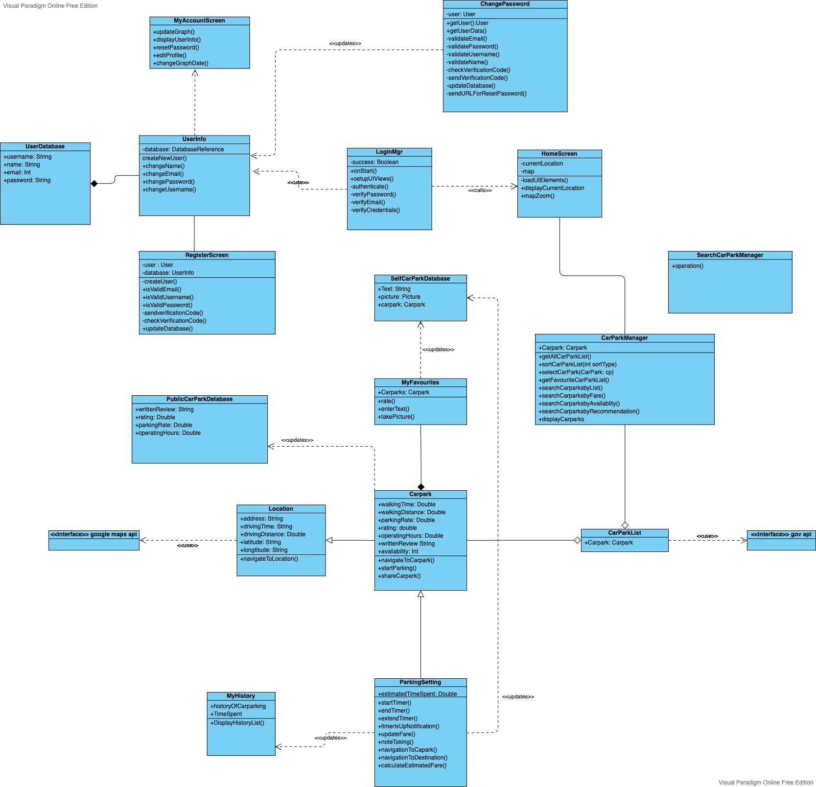

### 3.2. Key Boundary Classes and Control Classes

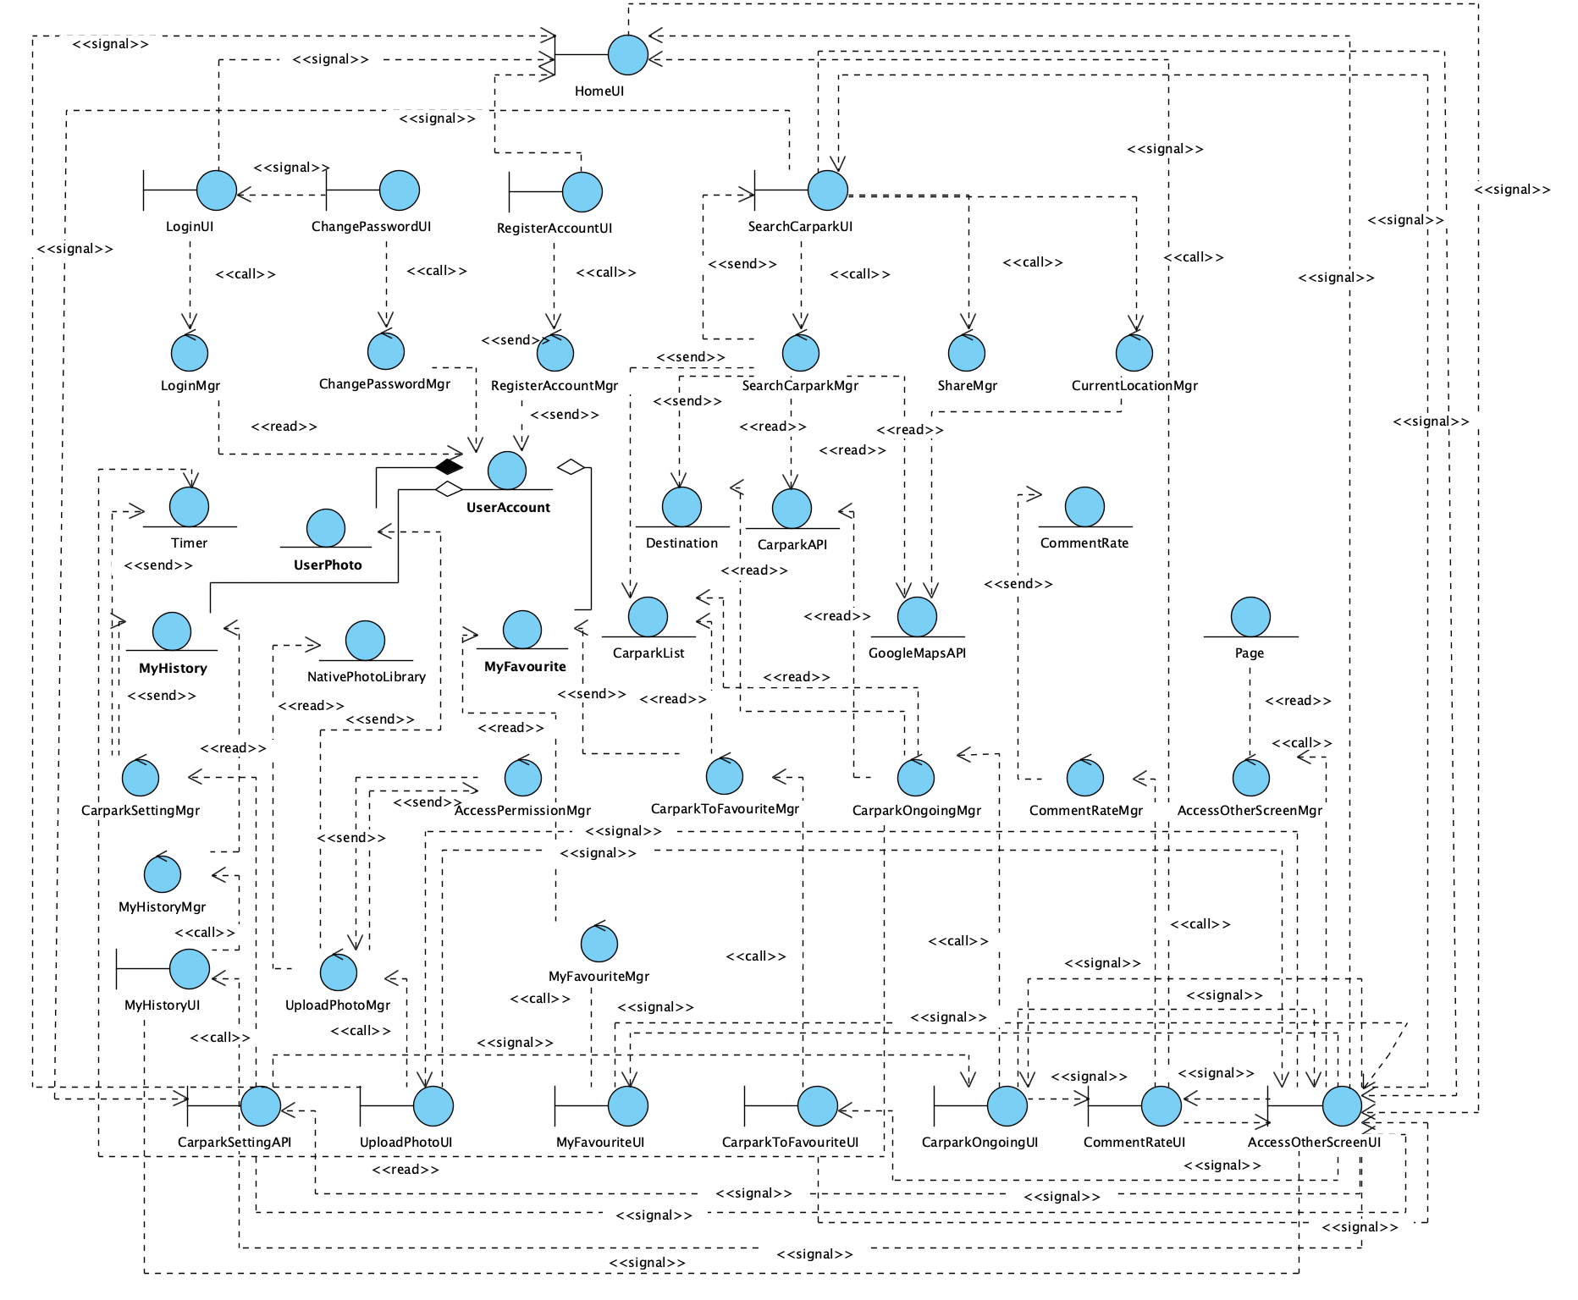

# 4. Build the Dynamic Model

### 4.1 Sequence Diagrams

#### 4.1.1. Login User Account Sequence

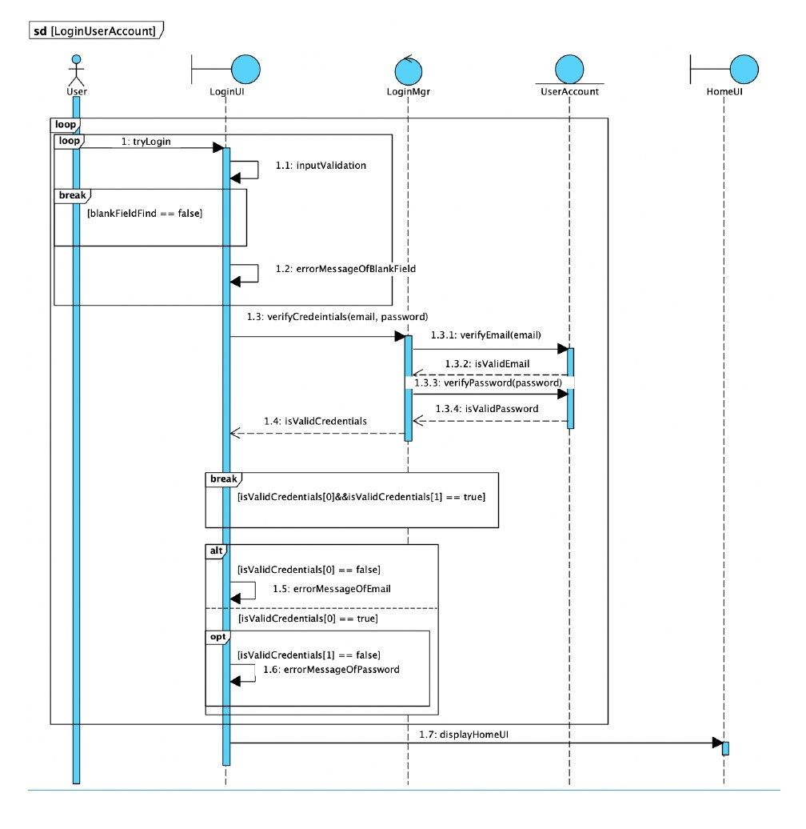

#### 4.1.2. Register New Account Sequence

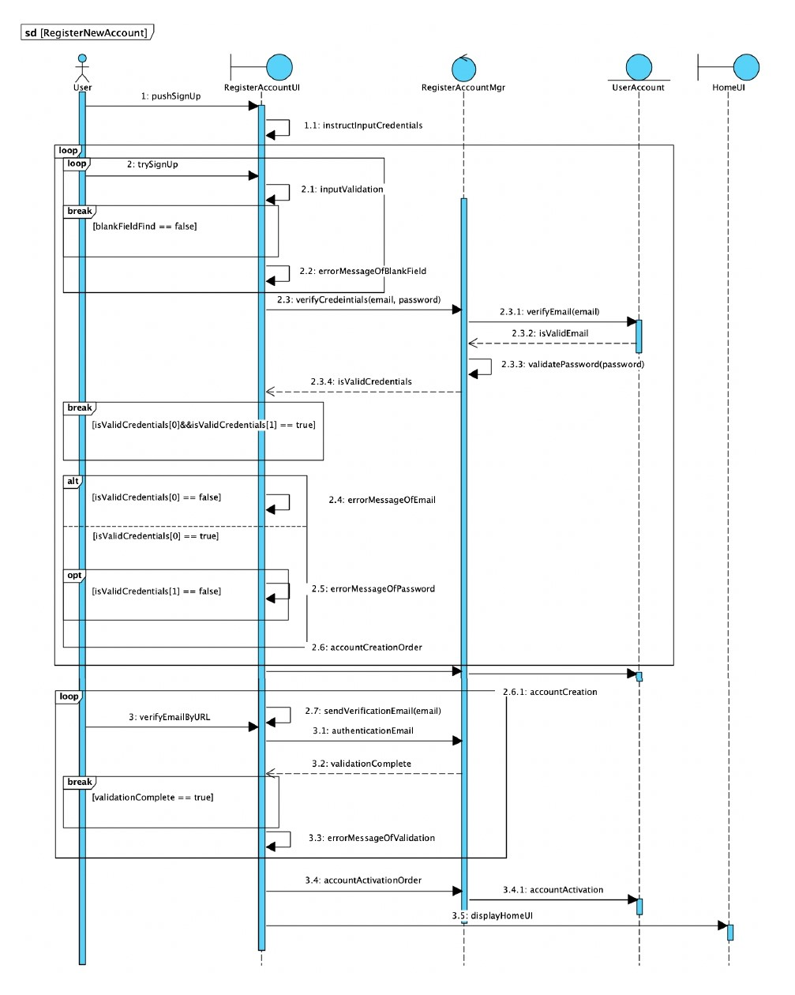

#### 4.1.3. Change Password Sequence

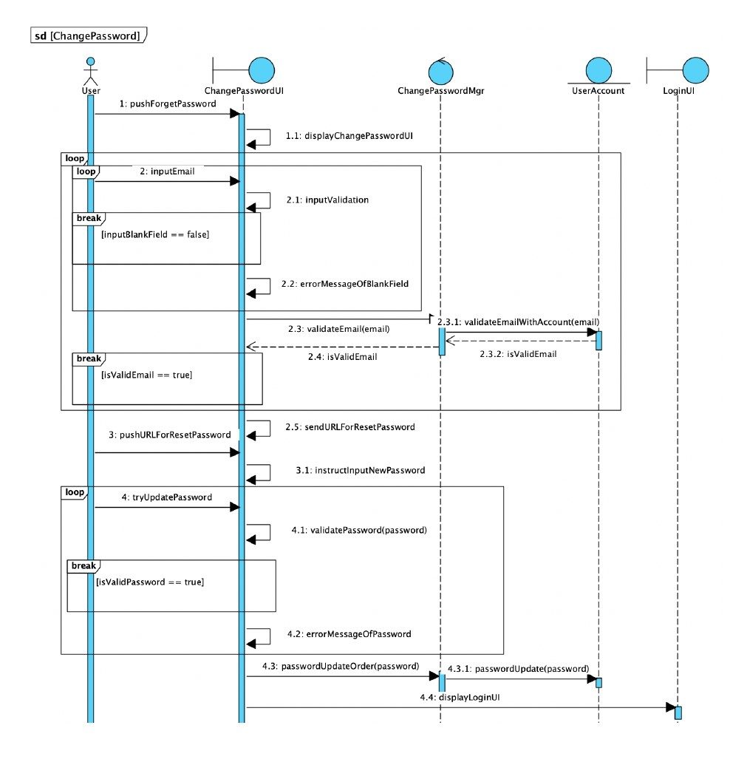

#### 4.1.4. Search For Carpark Location Sequence

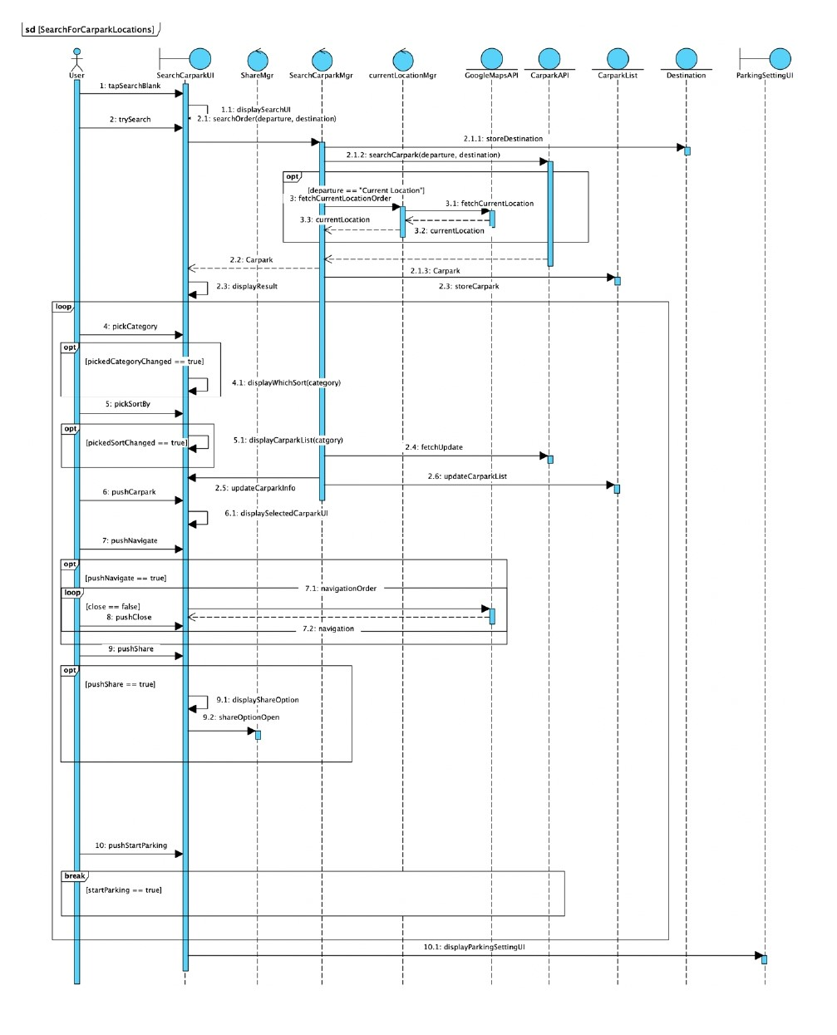

#### 4.1.1. Parking Setting Sequence

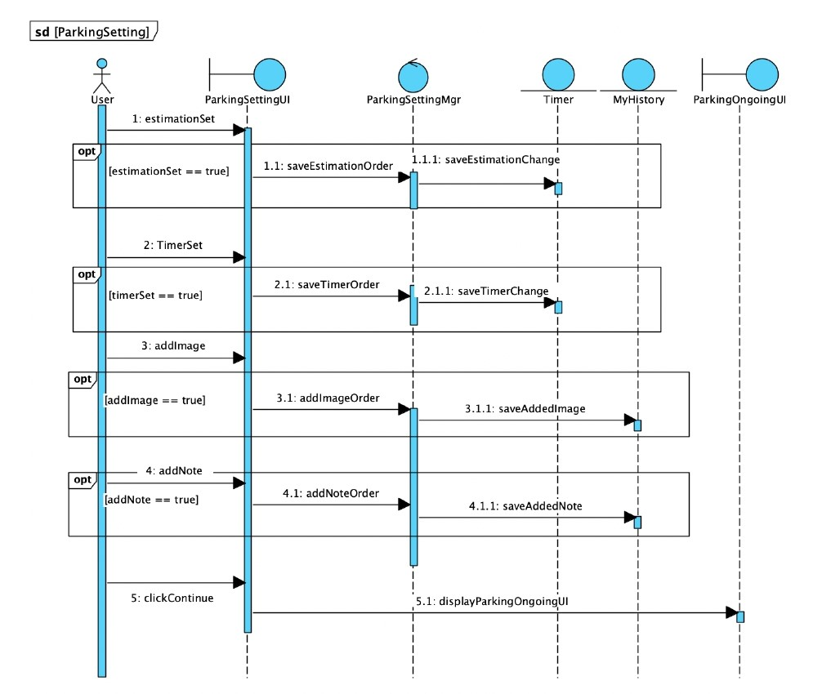

#### 4.1.5. Upload Photo Sequence

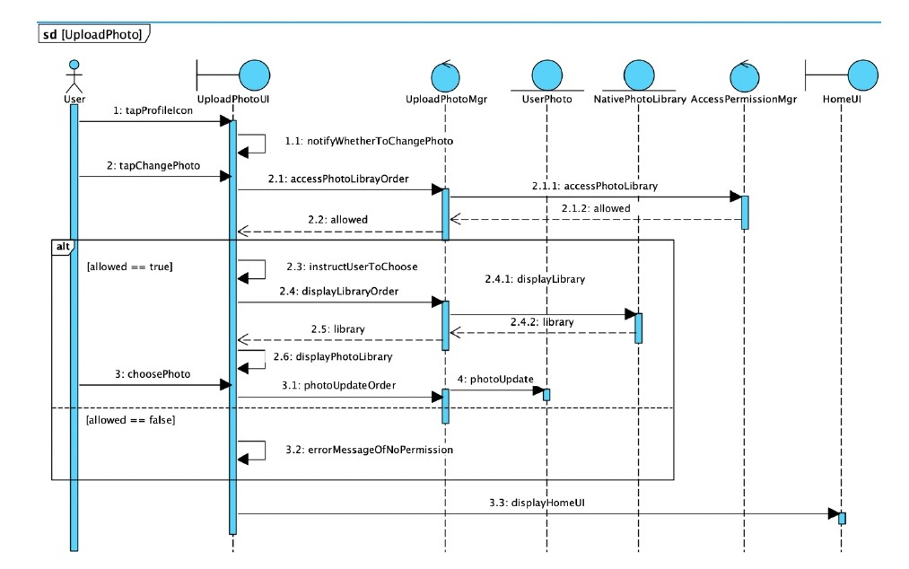

#### 4.1.6. My Favourite Sequence

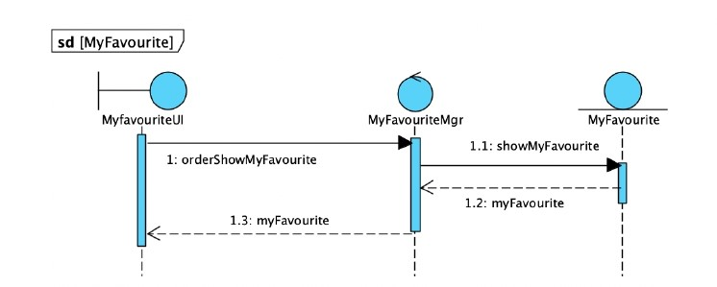

#### 4.1.7. My History Sequence

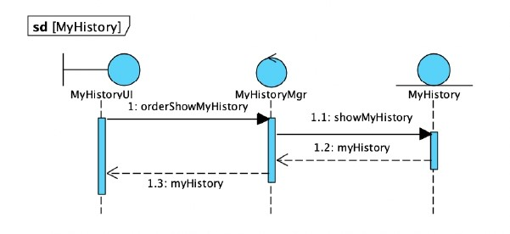

#### 4.1.8. Comment and Rate Sequence

#### 

### 4.2 State Machine Diagram

